Lecture Tutorial: Solar Sails and Other Spacecraft Propulsion

Description: In this activity, students consider why human travel outside of the solar system is currently unrealistic. By starting with current and proposed missions, students calculate how long it would take each mission to get to the next nearest stellar system—Alpha Centauri. They then learn the basics of ion thrusters, traditional rockets, and solar sails. Communication delays are also covered. Students then reflect on why space travel outside of our solar system is a difficult goal to attain.

Learning Goals:
- Calculate the time scales involved with traveling outside of the solar system and estimate how long it would take to travel to various destinations.
- Apply the concept of momentum to compare various types of propulsion methods that can be used to power spacecraft.
- Consider how long it takes to communicate with satellites orbiting various objects.
- Discuss realistic options for traveling outside of our solar system.

Prerequisite Ideas:
- Distinguish between speed and velocity
- Understand Newton’s 3rd law
- Understand the concept and formula for momentum

Instructor Notes:
- This activity pairs well with the Migration to Mars lecture tutorial.
- This activity is typically used in a unit on the solar system, with an emphasis on distances and time scales.
- Websites and QR codes are added for students who would like more information. This activity can be completed without accessing these outside sources, except for Part IV.


Read Me: Mission Backgrounds
Exploring our solar system is possible with current technology. The NASA Dawn mission traveled to two dwarf planets in the asteroid belt. Visiting both Ceres and Vesta, the purpose of this mission was to help us better understand the evolution of our solar system.


We have sent people to the Moon, and NASA plans to do so again within the next ten years. Space X has started sending astronauts to the International Space Station, and is also planning a human mission to Mars. With current technology, that trip will take 6 months, one-way.


Robotic missions have also reached the edge of our solar system. The Voyager missions left Earth in 1977 and have gone beyond the solar system, having entered interstellar space within the last couple years.



More recently, the New Horizons mission did a flyby of Pluto on its way to the Kuiper belt. When launched, this mission was the fastest rocket built by humans to date.


If we want to explore the galaxy outside of our solar system, we need to think through how this will work. Some considerations for this include: Can we send people outside of our solar system? How long will that take? If not, what should a satellite system be designed to look for elsewhere? What are the energy requirements for these missions? How long will it take to communicate with a mission outside of our solar system, and what does that mean in terms of the scope of the mission? We will explore these questions in this activity.

A proposed mission beyond our solar system is Starshot. Traveling a fraction of the speed of light, this mission could visit another solar system using solar sails.

Part I: Timescales
Table 1 shows the characteristics of the missions described in the Mission Backgrounds section on the previous page.

Table 1: Spacecraft Parameters

 | Dawn | Space X  Starship | Voyager 1 | New Horizons | Starshot  (proposed)
Top speed | 9.9 ✕ 10⁵ km/day | 1.1 ✕ 10⁶ km/day | 1.4 ✕ 10⁶ km/day | 1.4 ✕ 10⁶  km/day | 5.2 ✕10⁹  km/day
Mass | 747 kg | 5x10⁶ kg | 722 kg | 478 kg | 10 g
Size | 2✕ 20 ✕ 2 m | 9 m wide  120 m high | .47 m ✕ 1.78 m (+ antenna) | 2 ✕ 2 ✕ 3 m | 5 m diameter

- Using information in the table above, calculate how many years it would take each vehicle to travel to Alpha Centauri, the nearest stellar system. We can do this by taking the distance to Alpha Centauri (4 ✕10¹³ km) and dividing it by the top speed for each vehicle. This will give us the time in days. Then we will divide that number by 365 to get the time in years. Two have been completed already as examples.
Dawn: $(4 x {10}^{13}km)\frac{1 day}{9.9 x {10}^{5} km}\frac{1 year}{365 days}=110,700 years$

Space X Starship:

Voyager I:$(4 x {10}^{13}km)\frac{1 day}{1.4 x {10}^{6} km}\frac{1 year}{365 days}=78,300 years$

New Horizons:

Starshot:

- Is it realistic to send humans to another solar system using current technology? Explain your reasoning.

Part II: Propulsion
NASA has launched many many missions into space. Different missions have various destinations, and they use different methods for propulsion. We’ll discuss three types of propulsion and one mission for each type of propulsion.

Momentum–particularly the conservation of momentum within a system–is key for understanding how rockets work. Momentum is related to the motion that a moving object has. It is represented by p and is calculated by multiplying the mass of an object by its velocity.
p = mv

Thrust is the force that accelerates the rocket through the air and through space. Thrust is generated by the propulsion system of the rocket by the concept of conservation of momentum within a system: as the gas moves away from the rocket, the rocket moves away from the gas. Both parts of the system (i.e., the rocket and the gas) accelerate but in opposite directions.

In traditional or chemical rockets (Figure 1), hot gas exhaust is pushed out from the back, moving the rocket forward. These rockets take tons of liquid and solid fuel, and light it on fire with an oxidizer in order for the rocket to gain momentum. The gas likewise gains momentum, but because its velocity points in the opposite direction, the total momentum of the rocket-gas system is conserved.

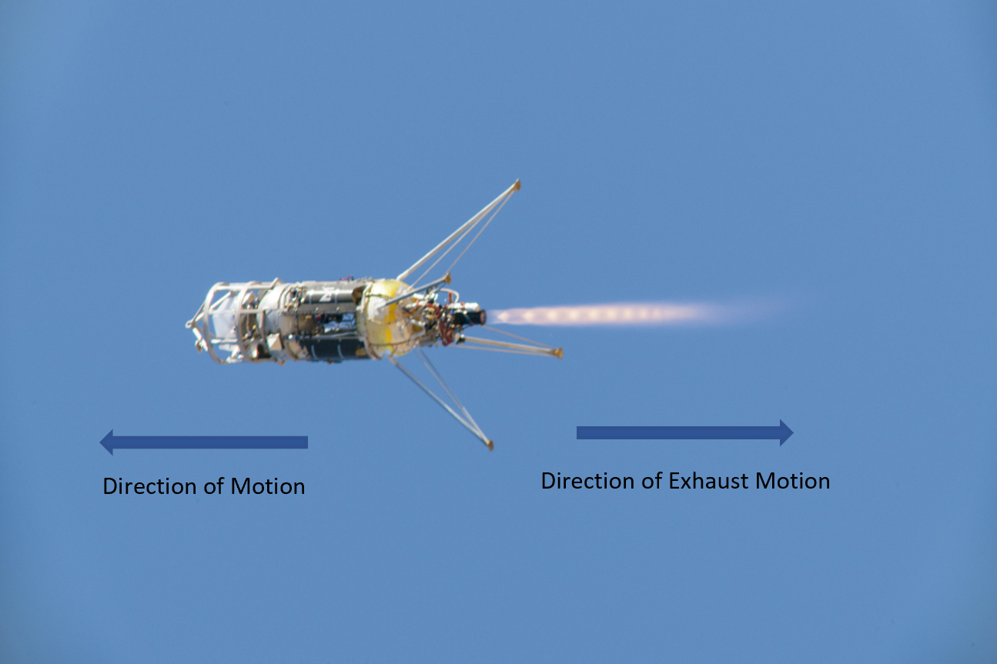

Figure 1. In a chemical rocket, mass (usually high temperature gas) is ejected from the back, moving the rocket forward. Credit: NASA

Ion thrusters (Figure 2) eject ions instead of combustion gasses to create thrust. The propellant is an inert gas like xenon that becomes ionized in a vacuum chamber in the rocket. Positive ions are then accelerated out of the back of the rocket by an electric field.

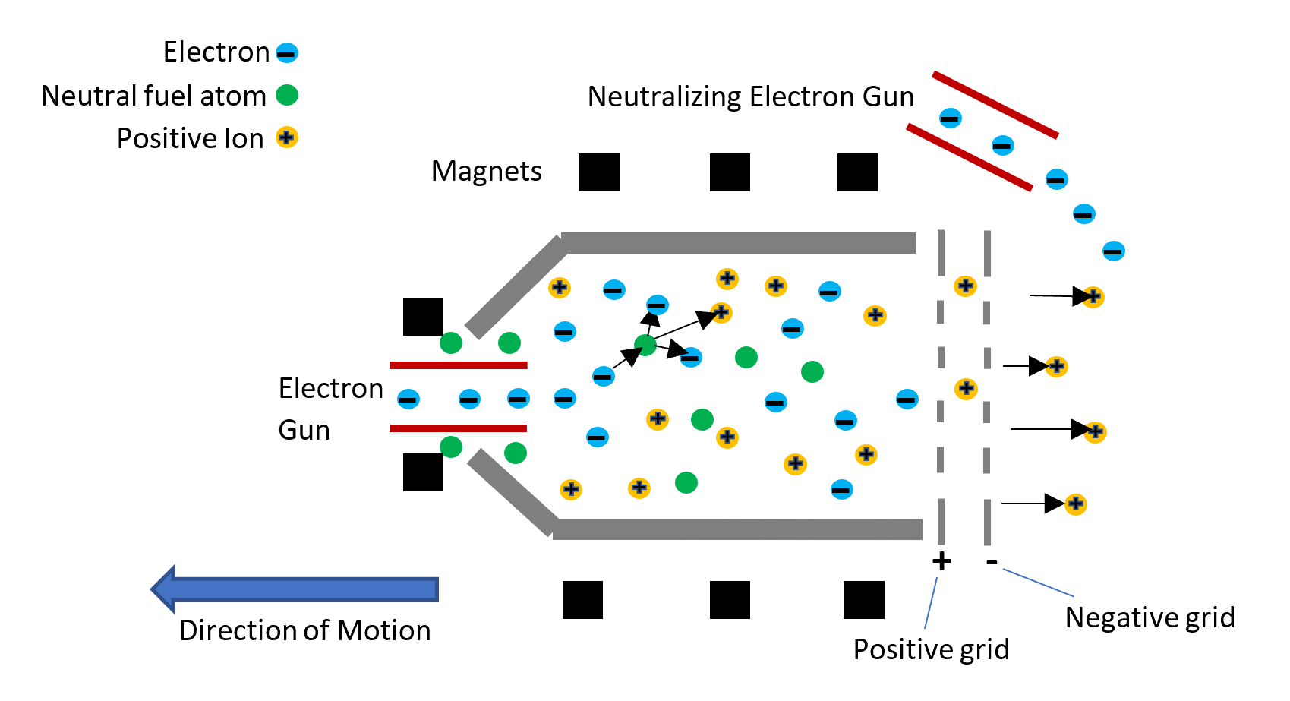
Figure 2. In ion thrusters, the propellant is ionized by high-energy electrons shot from an electron gun. Each electron collides with a neutral atom and produces another electron and a positive charge. Positive charges are accelerated toward a negative grid in the back of the rocket, providing the thrust for the rocket to move forward. Credit: Bahereh A. Samie

Individual ionized atoms can be ejected at a velocity of 90 km/s, whereas the most efficient chemical rockets have an exhaust gas velocity of 8 km/s. In ion thrusters, every atom that has gained a high velocity can create a small thrust on the rocket to move it forward.

- Look at the formula for momentum given on the previous page, and propose a reason why ion thrusters provide less thrust in the beginning compared to chemical rockets even though they eject particles at a much higher velocity.

- As stated above, ion thrusters use an inert gas as their propellant. How could using an inert gas as fuel be an advantage compared to chemical rockets? Explain.


NASA’s New Horizons spacecraft, launched in 2006 to study Pluto, was the fastest man-made object ever launched from Earth at a speed of 16.5 km/s. In order for New Horizons to orbit around Pluto, it would need to burn 580 times its own weight of fuel. Dawn is NASA’s first interplanetary mission to be propelled by ion thrusters.

- If New Horizons was equipped with an ion engine like Dawn’s, how might that alter the New Horizons mission?

Solar sailing is a revolutionary way of propelling spacecraft through space. Solar sails (Figure 3) use large, lightweight, mirror-like surfaces that capture the momentum from sunlight to push the spacecraft forward. Light is made up of massless particles called photons. Photons transfer their momenta (plural of momentum) to the spacecraft as they hit its reflective surfaces. Like in ion thrusters, every photon that hits the sails can create a small thrust forward. The Starshot mission will use solar sails to travel to the star system nearest our solar system, Alpha Centauri.

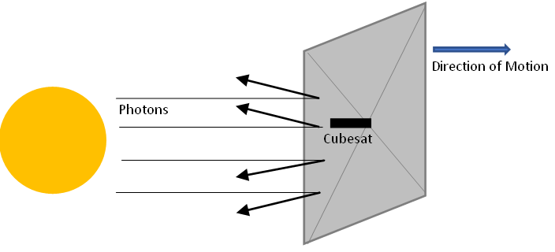
Figure 3. Momentum transferred by light particles bouncing off the slightly curved surface of a solar sail moves the sail forward. Credit: Bahereh A. Samie

- A solar sail’s velocity depends on its size and its mass. Discuss the pros and cons to using a larger sail.

- How does the distance from the Sun affect a solar sail’s acceleration? Explain.

- Name one similarity and one difference between ion thrusters and solar sails.

- Name three advantages of solar sails over traditional rockets. Are there any disadvantages? Explain.

Part III: Communications with the Mission
Missions in space need to be able to communicate with Earth. They typically do so using radio waves. Recall that radio waves are a kind of light, so they travel at the speed of light. Table 2 lists several current missions and their locations. Also listed is the proposed Starshot mission.

Table 2: Current Missions and Communication Delays

Mission | Chang’e 5 (China) | Perseverance | Juno | New Horizons | Voyager 1 | Starshot
Mission Target | Moon | Mars | Jupiter | Kuiper belt | Beyond solar system | Alpha Centauri
Communication Delay | 1.3 seconds | 12 minutes | 43 minutes | 7 hours | 21 hours | 4 years

- Consider how long it would take for Starshot to send a signal to Earth and for us to send a return signal using Table 2. What would you program the spacecraft to look for in this system? Why?



Part IV: Exploration outside of our solar system
Go to Wikipedia to view a map of the nearby stellar neighborhood and find our nearest stellar neighbor, Alpha Centauri. In this map, each concentric circle represents one light year from the Sun.

- Assuming Starshot could not change its direction, what would it encounter after visiting the Alpha Centauri triple-star system?

