Lecture Tutorial: Measuring the Velocity of a Coronal Mass Ejection

Description: This data analysis activity requires students to collect position and time data from NASA’s Solar and Heliospheric Observatory (SOHO) coronagraph images to make meaning of constant velocity motion and its graphical representations. This resource is designed to supplement Lecture-Tutorials for Introductory Astronomy for lecture-style classrooms.

Prerequisite:
● Understand the definition and calculation of average velocity.

Learn more about solar activity by reading
“A Space-Age Portrait of the Active Sun”
in The Physics Teacher by
David E. McKenzie and Timothy F. Slater.
http://aapt.scitation.org/doi/pdf/10.1119/1.879905

Instructions:
In this activity, you will analyze a set of coronagraph images captured by the NASA’s SOHO (Solar and Heliospheric Observatory), which is a camera that takes images of the Sun. The coronagraph is especially helpful for observing coronal mass ejections (CMEs). A CME occurs when the Sun ejects a blob of plasma. These clouds of high-energy particles can come toward Earth, damaging satellites above Earth, causing aurorae in the upper atmosphere, and even occasionally interfering with the electric grid on the surface of Earth.
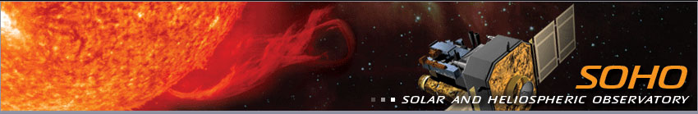
Credit: NASA
Knowing how fast these CMEs move when coming toward Earth is important, so that space weather scientists can adequately warn astronauts, pilots, and people on the surface of Earth that damage might be caused if precautions are not taken.

Section 1: Collect Data for Positions and Times of a CME

- Watch the video of CMEs shown by your instructor. (Or, see a variety of CME videos from SOHO here: https://sohowww.nascom.nasa.gov/bestofsoho/Movies/flares.html). Based on these videos, what kinds of questions might we be able to ask? List at least 3.

- Using a set of coronagraph images with your partner, identify a feature of the CME that you can follow from screenshot to screenshot. Similar to clouds, CMEs often change shape, but identifying features can be used to estimate measurements.

a) What feature did you choose? Why?

b) Use a ruler to quantify the changes in position of your identifying feature. Where will you start and end your measurements? Why?

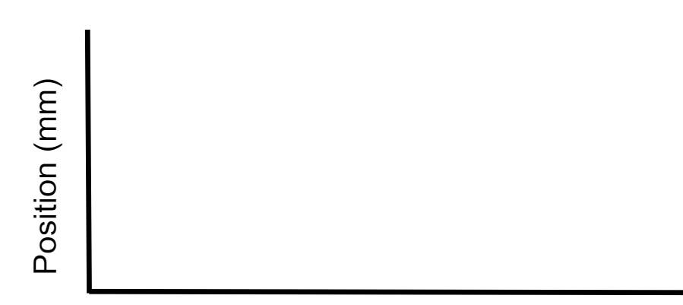
- What do you predict the shape of a position vs. time graph for this CME will look like? Include a rough sketch to the right. (Do not use any numbers.) Below, explain why you think it will look this way.

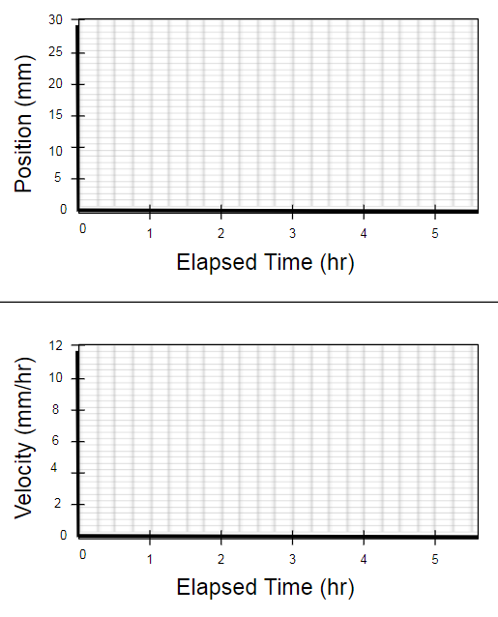

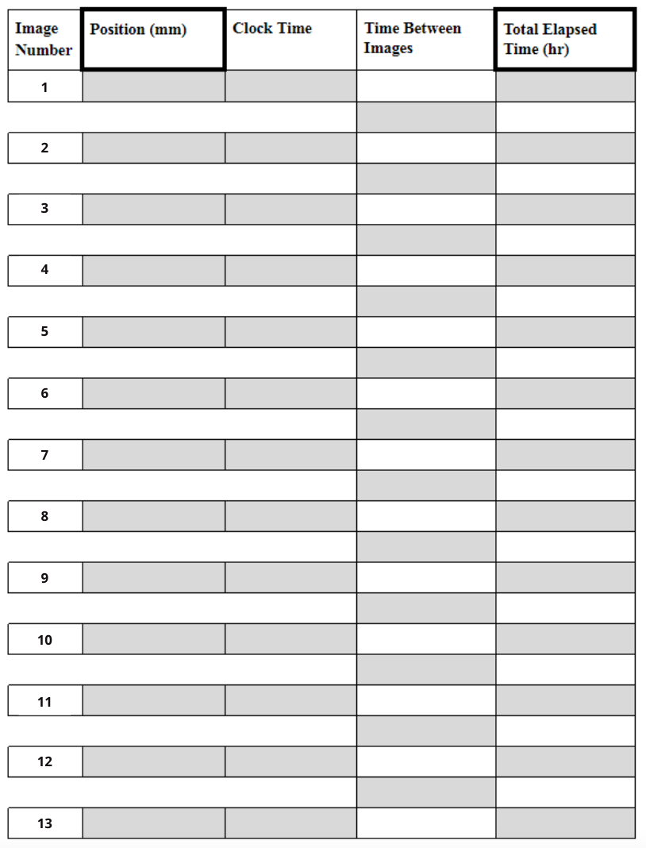

- To analyze the motions of the CME in your images, collect position and time information. For now, measure position in terms of mm using the ruler provided to you. Complete the table to the right by filling in the shaded boxes.

- Use the data from your table to plot an actual position and time graph on the Data Graphing Sheet (at the end of the packet).

- How does your actual plot (Data Graphing Sheet) compare to your predicted plot (#3)? Explain why you think any differences exist.

- Describe the motion of the CME in a brief paragraph below. Carefully describe changes in position from image to image.

Section 2: Estimate Average Velocities of Time Intervals

- On the position versus time graph (Data Graphing Sheet), calculate the average velocity for each segment and label it. Explain how you will do this, and give a sample calculation to show your work for at least one of the time intervals.

- Use the average velocities for each time interval to create a graph of velocity and time on the Data Graphing Sheet.

- Is the speed of the CME constant? Explain how you know.

Section 3: Analyze Velocity Graphs

- Look closely at the position versus time graph and its corresponding velocity versus time graph (Data Graphing Sheet). What general rule can you infer about the slope of the position graph and the value of the velocity graph?

- On your velocity versus time graph, shade in the area between the lines and the x-axis. Roughly calculate the sum of the areas you have shaded in, measuring the height in terms of mm/hr, and the base for each interval in terms of hr. Show your work.

- How does the value for the area under the velocity graph compare to the change in position (displacement) on the position graph?

Section 3: Compare x-t and v-t graphs for Different CMEs

- Compare your data to someone else who used a different image set.

a) How is the motion of their CME different?

b) How do their graphs of position and velocity look different?

- Imagine that your CME did the following:
  - For the first two hours, moved at a fast constant velocity, then
  - instantaneously began moving at a much slower constant velocity for the next two hours, then
  - instantaneously began moving at an even faster constant velocity than with which it started for the remaining time displayed on the graph.
Draw the corresponding graphs below.

Section 4: Use Proportional Reasoning to Estimate Time of Arrival of CMEs to Earth
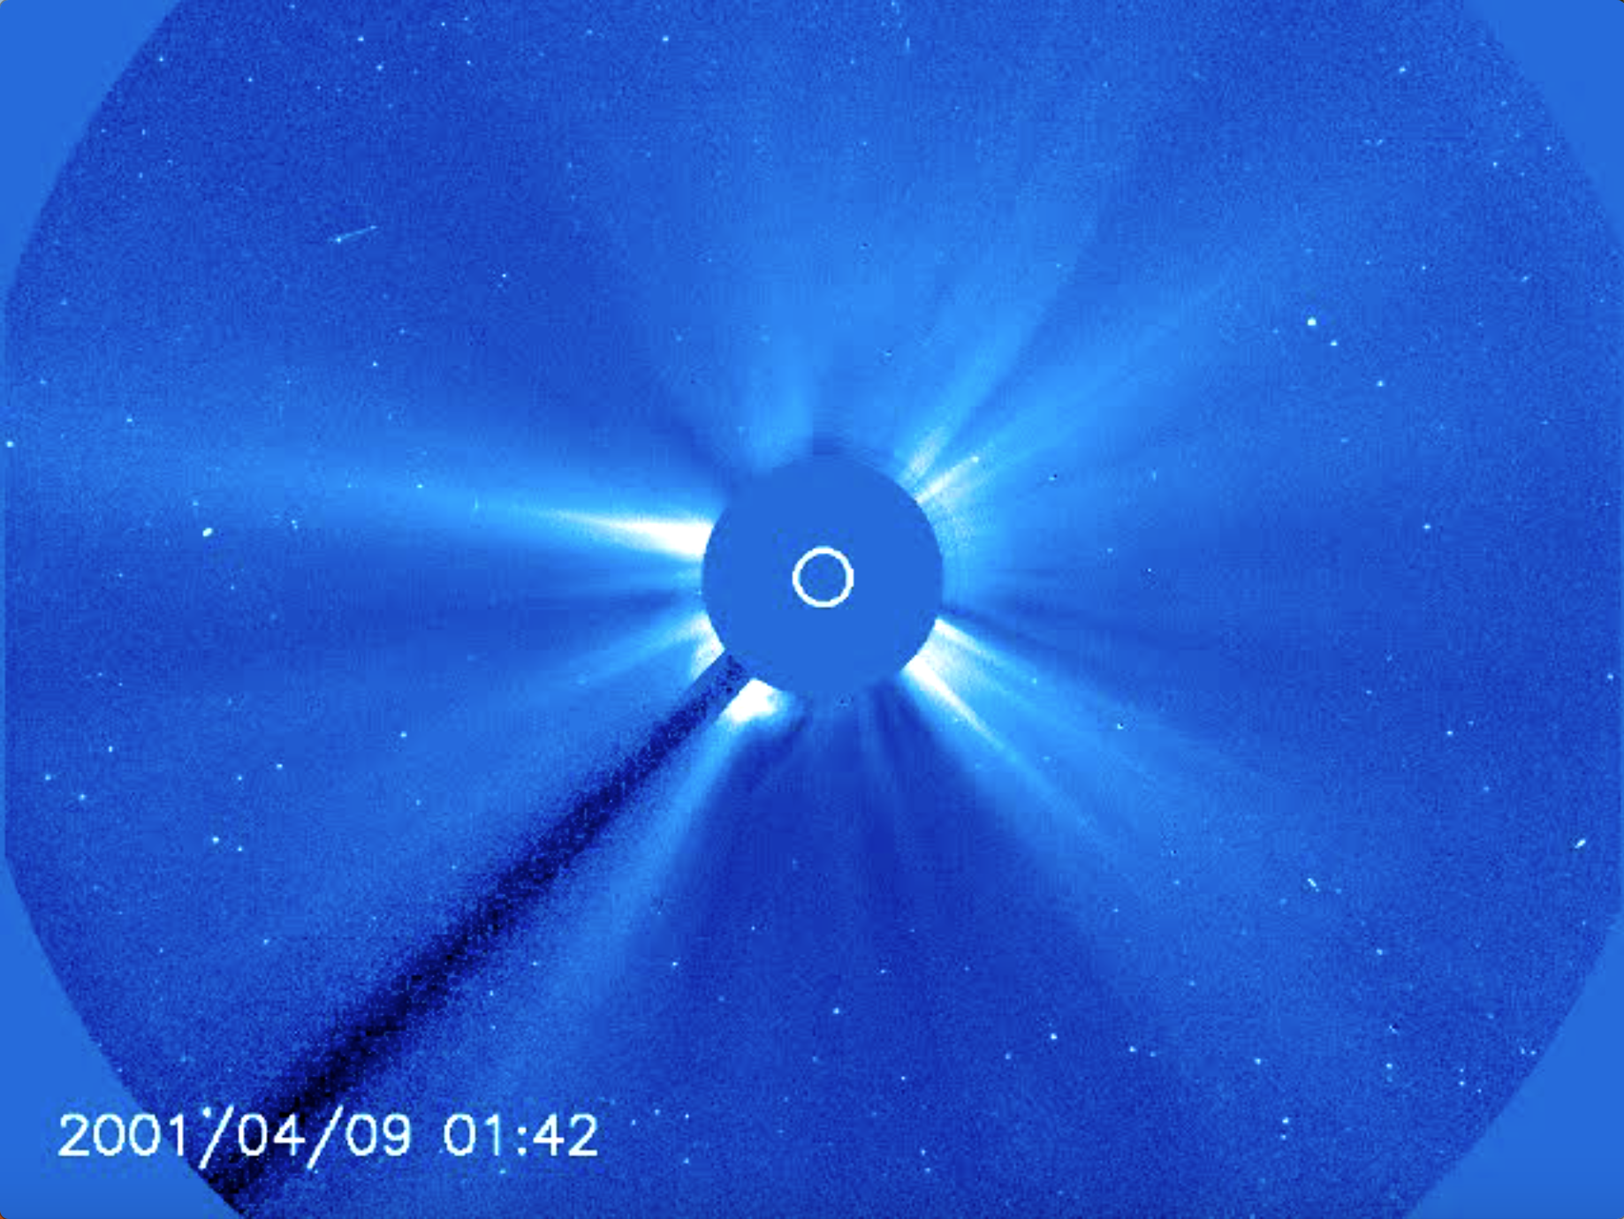
While using mm/hr is a convenient way to study general types of motion, it is more meaningful to convert these speeds to km/hr in order to estimate how long it will take for solar flares from CMEs to get to Earth.

- Note that all images on your image set show a small, white circle. This circle represents the outline of the Sun. (The larger blue circle is a plate suspended by a bar that blocks out the most intense light of the sun, allowing SOHO to perceive the CMEs.) Using your image set (not the image to the right, which has different dimensions), determine the diameter of the Sun in mm.

- The diameter of the sun is 1,391,400 km wide. How many km is represented by one mm?

- Using the last velocity recorded on your Data Graphing Sheet, estimate the velocity of the CME in km/hr. Convert this velocity to km/s (the standard units of CME velocity). Show all work.

- On average, the Sun is 149,600,000 km from Earth. At the speed calculated above, how many hours will it take for the CME to reach Earth, assuming it maintains a constant speed? Show all work.

Data Graphing Sheet

