Directions for Recording Talent Marketplace Videos
It is easy to record a 5-7 minute video in Teams and upload it to your Talent Marketplace application. If you have any questions or concerns, please contact Amy Treat at amy.a.treat@nasa.gov or Paola Ortiz at paola.c.ortizperez@nasa.gov.
- Create a meeting invite in Outlook and invite yourself to “Record LEADS Video.”

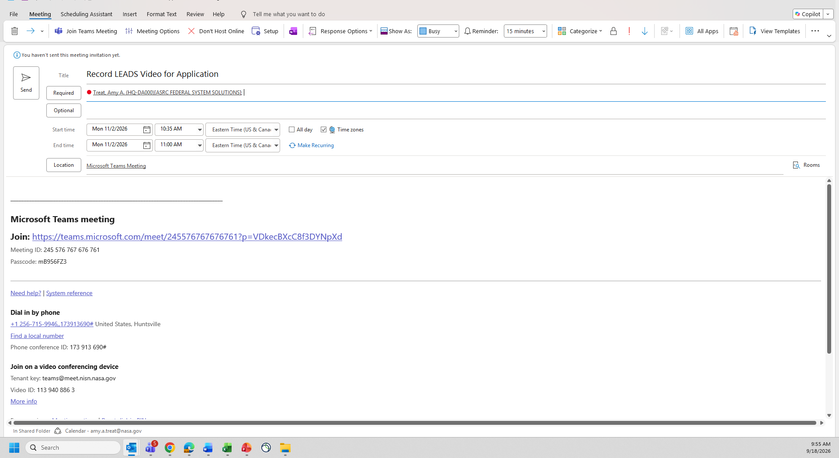
- Join the meeting in a new Teams window. Make sure you are sitting comfortably in a quiet location. Once you are in the meeting, click on More (…). Choose Record and Transcribe. Then Start Recording.

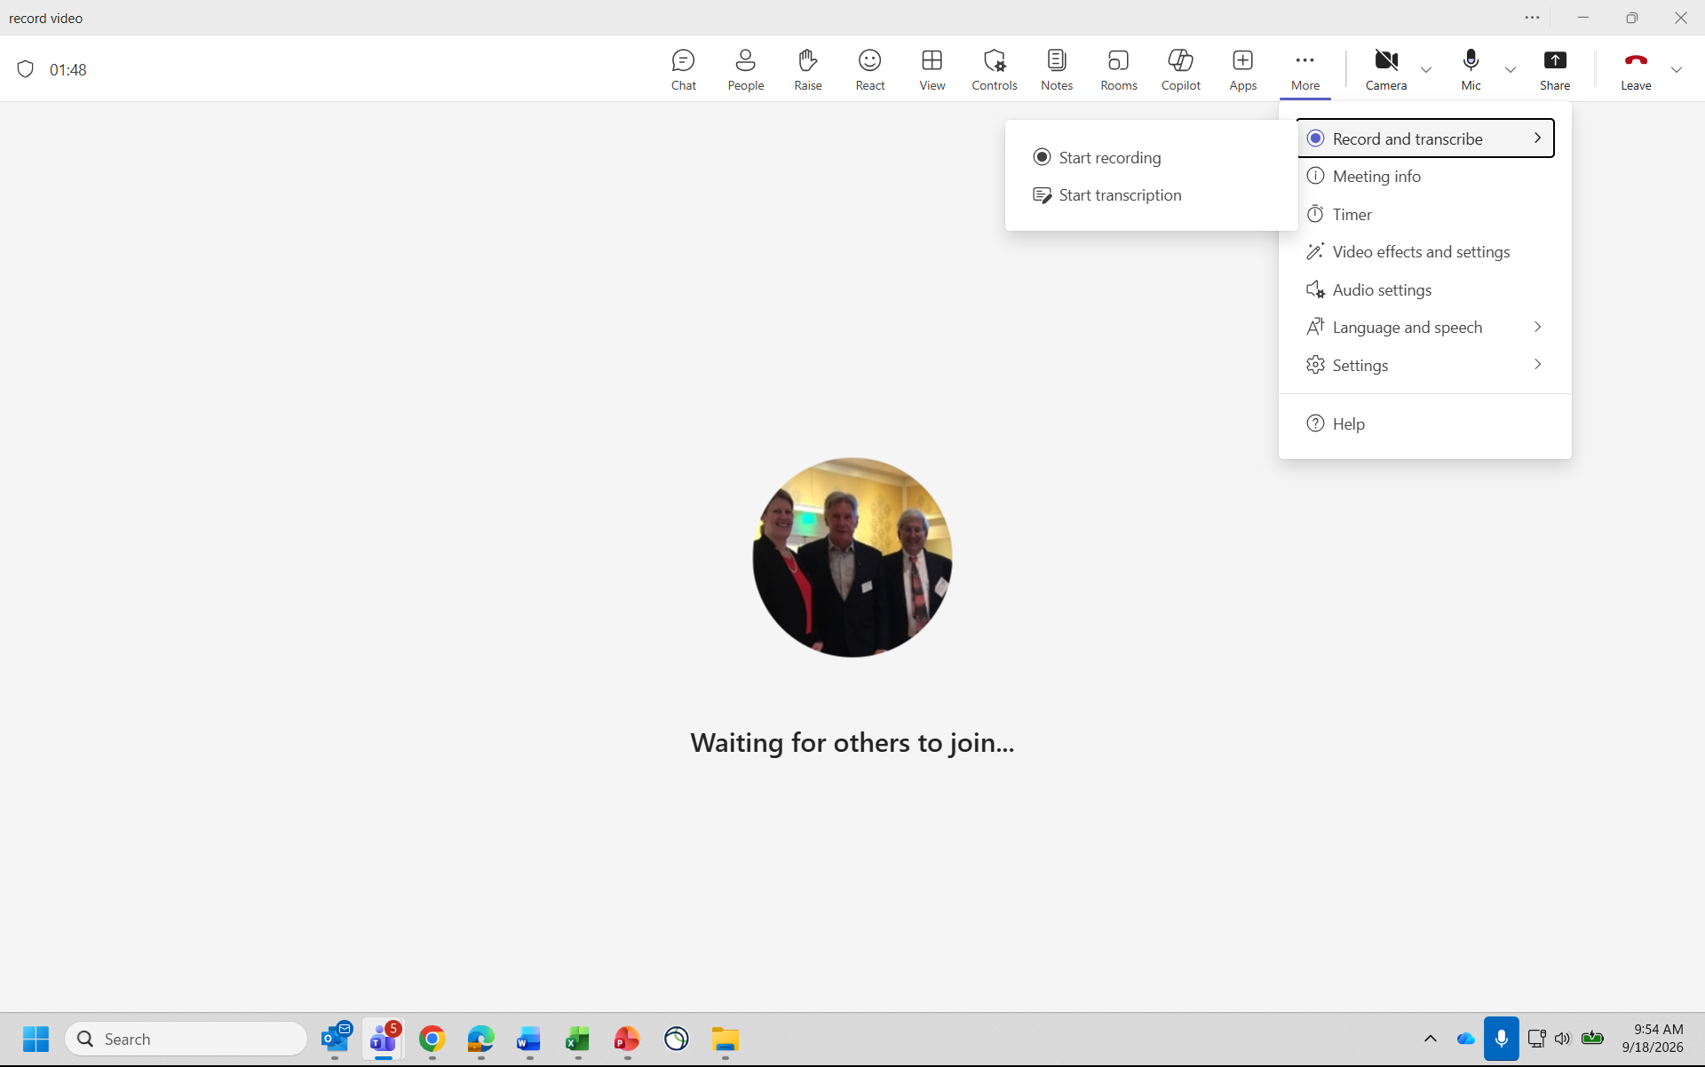

- Make sure you are recording your video in English and record Video and Audio.
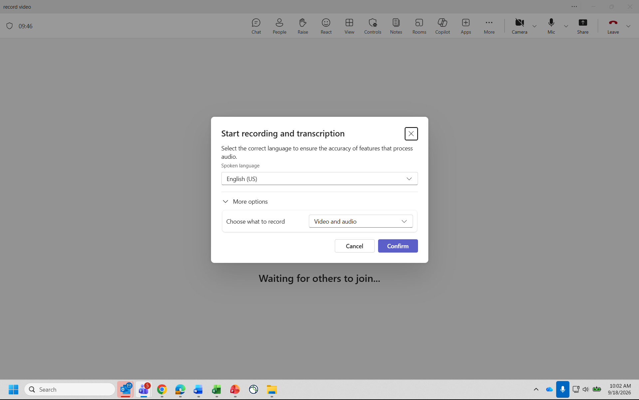

- When you are finished recording, go back to the More (…) and choose Stop Recording. The file will automatically save to your OneDrive.

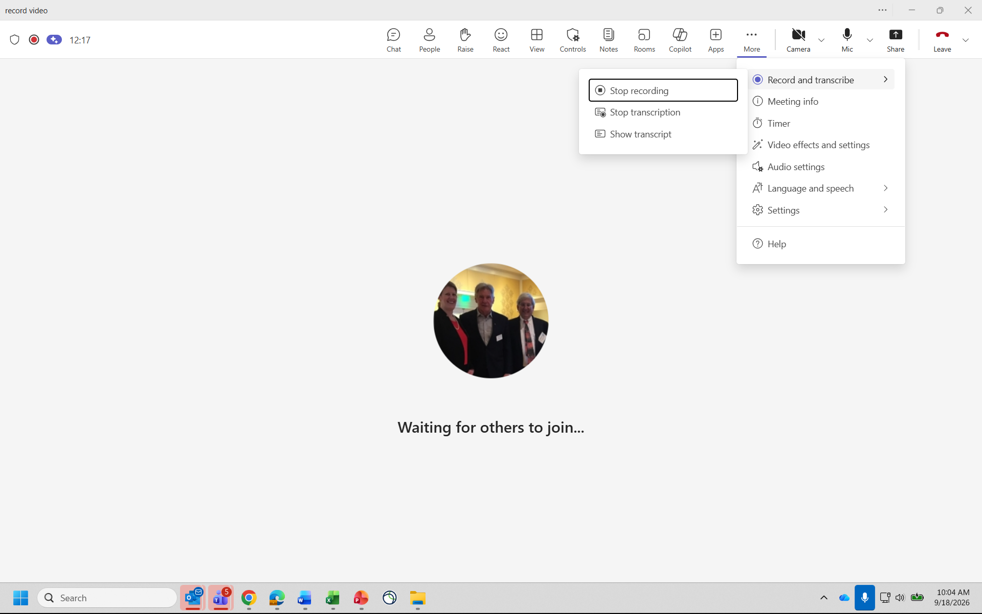

- Go to OneDrive and sign in with your work account. Click on My Files in the left sidebar.

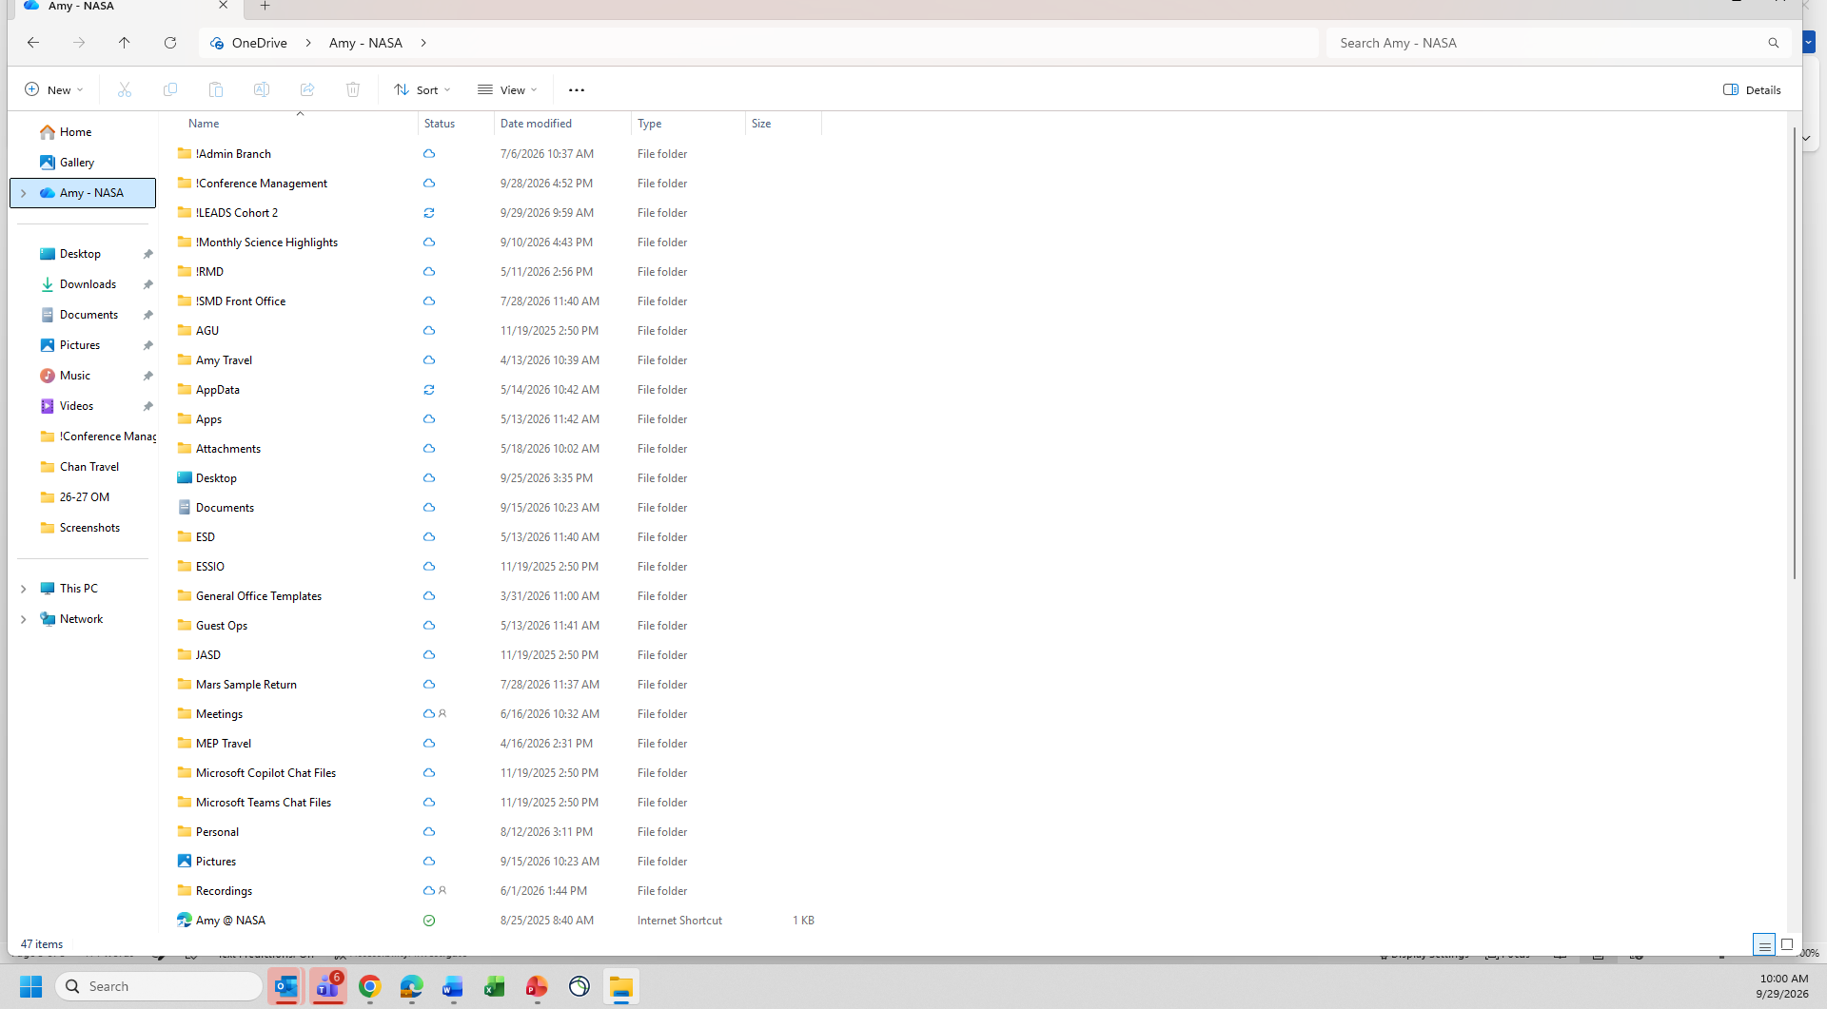

- Open the folder named Recordings and find your video file.

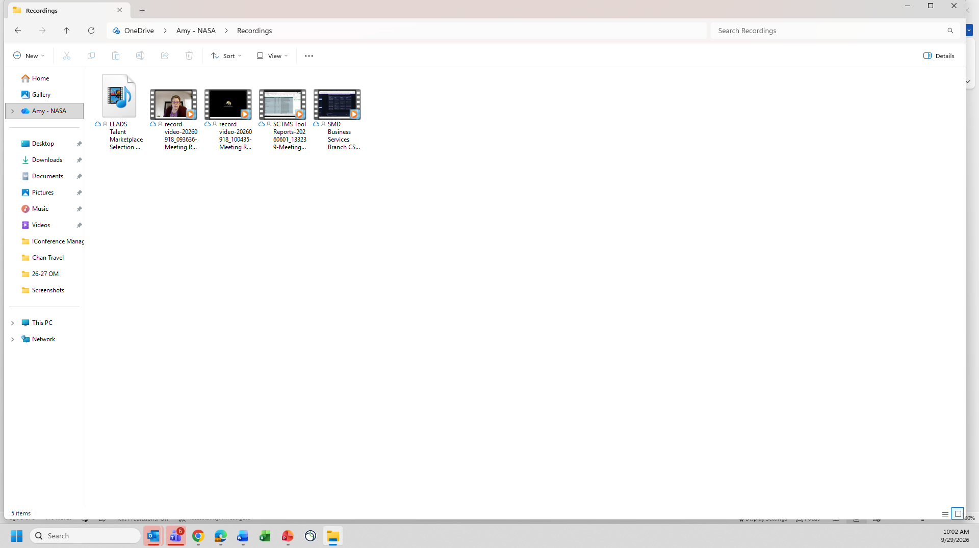

- Go to your application and click Attach or Upload, then select the downloaded file.

